Title:
Rational Design of Antibiotic Treatment Plans

Authors (in alphabetical order until we decide upon final order, currently used as place holders and to ensure spelling and institutional affiliations are correct. Please check yours.)
Miriam Barlow¹
Kristina Crona²
Juan C. Meza¹
Portia K. Mira¹
Bernd Sturmfels³

Institutional Affiliations:
¹School of Natural Science, University of California, Merced
² Department of Mathematics, American University
³ Department of Mathematics, Statistics, and Computer Science, University of California, Berkeley

Key Words:
Adaptive Landscapes, Antibiotic Cycling, B-lactams, Antibiotic Resistance

Abstract:

Introduction
Antibiotic resistance is an inevitable outcome whenever antibiotics are used. There are many reasons for this: 1) As humans (also as eukaryotes), we are vastly outnumbered by bacteria in nearly all ways including total population size, biomass, genetic diversity, emigration, and immigration; 2) bacteria can use horizontal gene transfer to share resistance genes across distantly related species of bacteria, including non-pathogens; 3) compared to humans, bacteria have relatively few vulnerable target sites; 4) microbes are the sources of nearly all antibiotics that are used by humans. Given the overwhelming numbers of bacteria, the limited number of target sites, the numerous ways that they can infect humans, and that they have been exposed to antibiotics for billions of years, resistance to antibiotics used by human populations is unavoidable.

Once resistance is present in a bacterial population, it is exceedingly difficult to remove for several reasons: 1) If any amount of antibiotic is present in the environment, antibiotic resistance genes confer a large fitness advantage; 2) When antibiotics are not present in an environment, the fitness costs for carrying and expressing resistance genes are small to non-existent; 3) it is difficult to remove antibiotics from the environment. If humans were to completely abandon the use of antibiotics, resistance would persist for years.

Efforts to remove resistance genes from clinical environments by either discontinuing or reducing the use of specific antibiotics for some period of time, either through general reduction of antibiotic consumption or periodic rotations of antibiotics (cycling) have not worked in any reliable or reproducible way; indeed it would have been surprising if they had worked.

Since antibiotic resistance is unavoidable, it only makes sense to accept its inevitability and do the best we can within that framework. One possible approach for managing resistance is to accurately predict the responses that bacteria will have upon exposure to a particular antibiotic, and to plan an effective response in turn. In a previous publication, we proposed that this might be accomplished by rotating consumption of multiple antibiotics that are a) structurally similar, b)inhibit/kill bacteria through the same target site, and c) result in pleiotropic fitness costs that reduce the overall resistance of bacteria to each other. We showed an anecdotal, proof-of-principle example of how this might work with a series of -lactam antibiotics in which some would select for new mutations in the nearly ubiquitous TEM β-lactamase and others that would select reversions in TEM ultimately leading back to the wild-type (un-mutated) state.

Our current work is to identify -lactam treatment plans that are the most likely to return a population expressing a small number of variant TEM enzymes to the wild-type state. The wild type TEM-1 and a handful of its descendants confer resistance to penicillins alone, while most of its descendants confer resistance to either cephalosporins or penicillins combined with β-lactamase inhibitors (inhibitor resistance), and a few confer resistance to both. Of the 194 TEM enzymes that have been identified, 174 (89.7%) differ from the wildtype TEM 1 by ≤4 amino acid substitutions (see Table 1). The rarity of the co-existence of cephalosporin resistance and inhibitor resistance and the fact that no single substitution confers both phenotypes suggested that sign epistasis (ie reversals from beneficial to detrimental) exists as the substitutions that contribute to this dual phenotype are combined.

The ability to push an evolved TEM enzyme back to the wild type state would limit the range of antibiotics to which it could confer resistance. To embark upon our effort to determine the best way of doing this, we decided to create a model system based upon the enzyme TEM-50, which differs from TEM-1 by four amino acid substitutions. All four substitutions by themselves confer clearly defined resistance advantages in the presence of certain antibiotics. Additionally TEM-50 is one of the few enzymes that simultaneously confers resistance to cephalosporins and inhibitor combined therapies.

Results
We first created all 16 variants of the four mutations found in TEM-50 using site directed mutagenesis (Table 2). We then measured the growth rates of E.coli DH5α-E expressing each variant in the presence of one of fifteen β-lactam antibiotics (Table 3).

There were 12 replicates for each sample in each antibiotic. We computed the mean and variance of each and computed significance between adjacent variants that differ by one mutation using one way ANOVA analysis.

We then plotted those results on maps (Figures 1-15) using arrows that connect each pair of adjacent enzymes. For each comparison of adjacent enzymes, we indicate the one whose expression resulted in the fastest growth by directing the arrowhead towards that variant, and implying that evolution would proceed in that direction if the two variants occurred simultaneously in a population. In other words, the one indicated by the arrowhead would increase in frequency and reach fixation in the population, while the other would be lost. Red arrows indicate significance, and black arrows indicate differences that were not statistically significant by ANOVA, but that may still exist if a more sensitive assay was used.

By rank ordering the enzymes (Table 4) in each landscape diagram, with the enzyme promoting the fastest growth being ranked “1” and the enzyme resulting in the slowest growth being ranked “16”, we found that all enzymes have a score of 5 or better and a score of 13 or worse, depending on the presence of specific antibiotics. This result indicates that there is abundant pleiotropy as antibiotic selective pressures change. This pleiotropy provides a basis for effectively alternating antibiotic to restore the wildtype.

The question of antibiotic cycling has been dealt with in many ways and there are recent studies to model the optimal duration of antibiotic exposures during antibiotic cycling (add reference ###). However, those models have not focused on developing a method for creating the ideal succession of antibiotics. Based on the strong patterns of pleiotropy we observed, we reasoned that the choice and the succession of antibiotics was at least as important as other cycling considerations. We formalized our approach for optimizing cycling based upon pleiotropy as follows: 1) We are considering 14 antibiotics, labeled AM, AMC, AMP, CAZ, CEC, CPD, CPR, CRO, CTT, CTX, CXM, FEP, SAM, TZP, and ZOX.

2) For each of these 14 antibiotics, we select exactly one TEM fitness landscape. Such a landscape is a real 2x2x2x2 tensor f = (fijkl). The indices i; j; k; l correspond to four mutations and exist in either state 0, which corresponds to no mutation at that site, or 1, which corresponds to a mutatation that is involved in the resistance phenotype at that site. We can identify f with a vector whose coordinates are indexed by {0; 1}⁴.

3) Our mutation model is a function M : R¹⁶ -> R^{16x16} that assigns a transition matrix to each fitness landscape. Recall that a transition matrix has nonnegative entries and its rows sum to 1. The rows and columns of M(f) are labeled by {0, 1}⁴, in some order that is fixed throughout. We require that our transition matrices respect the adjacency structure of the 4-cube, that is, M(f)a,b = 0 unless a and b are vectors in {0; 1}⁴ that differ in at most one coordinate. Thus each row of M(f) has at most 5 non-zero entries. We reasoned that resistant strains are most likely to be in competition with those that express a resistance allele immediately adjacent (varying by a single mutation) to the one they express. In our model, each allele has four alleles that are adjacent, since there are four mutations under consideration.

4) When compared, the strain with the fastest growth rate will be the winner, or the most fit, and increase in frequency in the microbial population until it was the primary genotype.

5) The ideal outcome we decided upon was a return from any mutated TEM allele back to the wild type state.

6)Having arrived at the wildtype state, it is ideal to limit the fixation of mutations away from that state as stringently as possible.

We used two probabilistic methods to determine the optimum (most probable) sequence of β-lactams for returning them to their wild type state. Briefly, the first method allows probabilities to be based upon the actual growth rates (Table 5) and the second method assumes that all arrows in the landscape plots are equally likely and that only the direction of the arrows is important.

Using the first method, we identified the most likely paths from each allele in our landscape back to the wildtype state using cycle lengths of either 2, 3, 4, 5 or 6 antibiotics. Those results are summarized in figure 16, (complete results included in supplementary data).

Using the second method, we obtained nearly identical results as shown in figure 17 (complete results included in supplementary data).

These results show the most likely paths for returning to the wildtype state from various starting points. Not all alleles were represented in those paths. We suspect the reason for this is ????????

Once returned to the wildtype state, we identified cycles that would return allow for alternation of antibiotics, and allow for some fixation of mutations, but then rapidly return bacteria to the wildtype state (Table 6). We found that in the most probable cases, only one mutation went to fixation, and then experienced a reversion and returned to the wildtype state.

Discussion
The exact cycles we have identified combine antibiotics that are used for vastly different infection types and in different clinical settings, and may not be broadly applicable for all situations. However, these results do illustrate the point that pleiotropy can be manipulated to reverse the evolution of antibiotic resistance.

While our exact results may not be broadly applicable, the underlying methods can be broadly applied. We have developed a mathematical approach for optimizing antibiotic cycling, and an experimental approach for measuring pleiotropy. These two methods provide the basic tools necessary for developing reasonable sequences of antibiotic therapies that should be able to restore susceptibility to select antibiotics in microbial populations.

Table 1
Number of mutations | Number of TEM enzymes
1 | 53
2 | 53
3 | 37
4 | 31
5 | 10
6 | 2
7 | 2
8 | 0
9 | 0
10 | 1
11 | 1

Table 2 Variant Enzymes Created, Binary Codes and Names of Enzymes Identified in Clinical Isolates
Number of Substitutions | Binary  Enzyme  Code | Variants with substitutions found in TEM-50
0 | 0000 | No Mutations  (TEM-1)
1 | 1000 | M69L  (TEM-33)
1 | 0100 | E104K  (TEM-17)
1 | 0010 | G238S  (TEM-19)
1 | 0001 | N276D  (TEM-84)
2 | 1100 | M69L  E104K  (Not identified)
2 | 1010 | M69L  G238S  (Not identified)
2 | 1001 | M69L  N276D  (TEM-35)
2 | 0110 | E104K  G238S  (TEM-15)
2 | 0101 | E104K  N276D  (Not identified)
2 | 0011 | G238S  N276D  (Not identified)
3 | 1110 | M69L  E104K  G238S  (Not identified)
3 | 1101 | M69L  E104K  N276D  (Not Identified)
3 | 1011 | M69L  G238S  N276D  (Not identified)
3 | 0111 | E104K  G238S  N276D  (Not identified)
4 | 1111 | M69L  E104K  G238S  N276D  (TEM-50)

Table 3 Antibiotics used for this study
Antibiotic | FDA approval | Antibiotic Group
Ampicillin (AMP) | 1963 | Aminopenicillin
Amoxicillin | 1972 | Aminopenicillin
Cefaclor(CEC) | 1979 | Cephalosporin
Cefotaxime (CTX) | 1981 | Cephalosporin
Ceftizoxime (ZOX) | 1983 | Cephalosporin
Cefuroxime (CXM) | 1983 | Cephalosporin
Ceftriaxone(CRO) | 1984 | Cephalosporin
Amoxicillin + Clavulanic acid (AMC) | 1984 | Penicillin derivative +  β-Lactamase inhibitor
Ceftazidime (CAZ) | 1985 | Cephalosporin
Cefotetan (CTT) | 1985 | Cephalosporin
Ampicillin + Sulbactam (SAM) | 1986 | Penicillin derivative +  β-Lactamase inhibitor
Cefprozil (CPR) | 1991 | Cephalosporin
Cefpodoxime (CPD) | 1992 | Cephalosporin
Pipercillin + Tazobactam (TZP) | 1993 | Penicillin derivative +  β-Lactamase inhibitor
Cefepime(FEP) | 1996 | Cephalosporin

Table 4 Rank order of enzymes in each antibiotic
 | 0000 | 1000 | 0100 | 0010 | 0001 | 1100 | 1010 | 1001 | 0110 | 0101 | 0011 | 1110 | 1101 | 1011 | 0111 | 1111
Amoxicillin | 8 | 11 | 14 | 3 | 7 | 12 | 6 | 4 | 15 | 10 | 13 | 9 | 1 | 5 | 16 | 2
Amoxicillin Clavulanate | 9 | 10 | 3 | 14 | 6 | 11 | 7 | 12 | 15 | 8 | 4 | 13 | 1 | 5 | 16 | 2
Ampicillin | 11 | 12 | 9 | 10 | 7 | 5 | 15 | 6 | 8 | 2 | 4 | 13 | 3 | 14 | 16 | 1
Ceftazidime | 10 | 15 | 11 | 8 | 6 | 7 | 12 | 14 | 1 | 4 | 3 | 2 | 5 | 13 | 16 | 9
Cefaclor | 4 | 12 | 3 | 7 | 9 | 8 | 5 | 14 | 6 | 1 | 10 | 2 | 15 | 16 | 13 | 11
Cefpodoxime | 13 | 14 | 7 | 6 | 16 | 12 | 5 | 15 | 4 | 3 | 8 | 11 | 10 | 9 | 2 | 1
Cefprozil | 7 | 9 | 3 | 6 | 8 | 13 | 16 | 11 | 2 | 5 | 1 | 4 | 12 | 14 | 15 | 10
Ceftriaxone | 10 | 11 | 4 | 7 | 16 | 8 | 2 | 14 | 6 | 3 | 13 | 5 | 12 | 9 | 15 | 1
Cefotetan | 12 | 3 | 2 | 10 | 13 | 16 | 9 | 7 | 6 | 15 | 8 | 4 | 5 | 14 | 1 | 11
Cefotaxime | 11 | 10 | 7 | 6 | 16 | 8 | 5 | 12 | 3 | 2 | 13 | 14 | 15 | 9 | 4 | 1
Cefuroxime | 11 | 16 | 2 | 7 | 12 | 8 | 10 | 15 | 4 | 9 | 6 | 14 | 13 | 5 | 1 | 3
Cefepime | 10 | 15 | 13 | 14 | 11 | 7 | 2 | 12 | 8 | 4 | 5 | 6 | 3 | 9 | 16 | 1
Ampicillin/  Sulbactam | 12 | 11 | 8 | 13 | 5 | 7 | 10 | 4 | 16 | 14 | 9 | 6 | 2 | 3 | 15 | 1
Pipercillin/  Tazobactam | 6 | 5 | 2 | 10 | 3 | 9 | 12 | 8 | 7 | 15 | 1 | 11 | 4 | 16 | 14 | 13
Ceftizoxime | 14 | 11 | 8 | 5 | 15 | 10 | 7 | 9 | 4 | 2 | 6 | 3 | 12 | 16 | 1 | 3
best value | 4 | 3 | 2 | 3 | 3 | 5 | 2 | 4 | 1 | 1 | 1 | 2 | 1 | 3 | 1 | 1
worst value | 14 | 16 | 14 | 14 | 16 | 16 | 15 | 15 | 16 | 15 | 13 | 14 | 15 | 16 | 16 | 13

Table 5 Average Growth Rates
 | 0000 | 1000 | 0100 | 0010 | 0001 | 1100 | 1010 | 1001
Amoxicillin | 0.0017775 | 0.00172 | 0.001448333 | 0.002041667 | 0.001781667 | 0.001556667 | 0.001799167 | 0.002008333
Amoxicillin Clavulanate | 0.001435 | 0.001416667 | 0.001671667 | 0.001060833 | 0.001573333 | 0.001376667 | 0.0015375 | 0.001350833
Ampicillin | 0.001850833 | 0.00157 | 0.002024167 | 0.001948333 | 0.002081667 | 0.002185833 | 0.0000508 | 0.002165
Ceftazidime | 0.002134167 | 0.000288333 | 0.002041667 | 0.002618333 | 0.002655833 | 0.00263 | 0.001604167 | 0.000575833
Cefaclor | 0.002258333 | 0.000234167 | 0.002395833 | 0.002150833 | 0.001995833 | 0.00215 | 0.002241667 | 0.000171667
Cefpodoxime | 0.000595 | 0.000431667 | 0.001760833 | 0.002604167 | 0.000245 | 0.0006375 | 0.002650833 | 0.000388333
Cefprozil | 0.001743333 | 0.001553333 | 0.0020175 | 0.0017625 | 0.001661667 | 0.0002225 | 0.000165 | 0.000255833
Ceftriaxone | 0.001091667 | 0.00083 | 0.00288 | 0.002554167 | 0.000286667 | 0.001406667 | 0.0031725 | 0.00054
Cefotetan | 0.002125 | 0.003238333 | 0.003290833 | 0.002804167 | 0.001921667 | 0.000545833 | 0.0028825 | 0.002965833
Cefotaxime | 0.00016 | 0.000185 | 0.001653333 | 0.001935833 | 0.000085 | 0.000225 | 0.001969167 | 0.00014
Cefuroxime | 0.0017475 | 0.0004225 | 0.00294 | 0.00207 | 0.0017 | 0.002024167 | 0.001910833 | 0.001578333
Cefepime | 0.00259 | 0.002066667 | 0.00244 | 0.002393333 | 0.002571667 | 0.002735 | 0.002956667 | 0.002445833
Ampicillin/  Sulbactam | 0.001879167 | 0.0021975 | 0.002455833 | 0.000133333 | 0.0025325 | 0.002504167 | 0.002308333 | 0.00257
Pipercillin/  Tazobactam | 0.002679167 | 0.002709167 | 0.0030375 | 0.002426667 | 0.002905833 | 0.002453333 | 0.000171667 | 0.0025
Ceftizoxime | 0.000993333 | 0.001105833 | 0.0016975 | 0.002069167 | 0.000805 | 0.001115833 | 0.001894167 | 0.001170833
 | 0110 | 0101 | 0011 | 1110 | 1101 | 1011 | 0111 | 1111
Amoxicillin | 0.001184167 | 0.001751667 | 0.001544167 | 0.0017675 | 0.002246667 | 0.002005 | 0.0000625 | 0.002046667
Amoxicillin Clavulanate | 0.0000733 | 0.001456667 | 0.001625 | 0.001306667 | 0.001914167 | 0.00159 | 0.0000675 | 0.0017275
Ampicillin | 0.0020325 | 0.002434167 | 0.0021975 | 0.0000875 | 0.002321667 | 0.0000825 | 0.0000342 | 0.002820833
Ceftazidime | 0.002924167 | 0.0026875 | 0.002755833 | 0.002893333 | 0.002676667 | 0.001378333 | 0.000250833 | 0.0025625
Cefaclor | 0.00223 | 0.0026475 | 0.001845833 | 0.00264 | 0.000095 | 0.0000933 | 0.000214167 | 0.000515833
Cefpodoxime | 0.00291 | 0.0030425 | 0.001470833 | 0.0009625 | 0.000985833 | 0.0011025 | 0.003095833 | 0.003268333
Cefprozil | 0.002041667 | 0.001785 | 0.00205 | 0.001810833 | 0.000239167 | 0.000220833 | 0.002175 | 0.000288333
Ceftriaxone | 0.002731667 | 0.003041667 | 0.000655833 | 0.00274 | 0.000750833 | 0.0011525 | 0.000435833 | 0.003226667
Cefotetan | 0.003081667 | 0.0005875 | 0.0028875 | 0.0031925 | 0.003180833 | 0.00089 | 0.0035075 | 0.002543333
Cefotaxime | 0.002295 | 0.0023475 | 0.0001375 | 0.000119167 | 0.0000917 | 0.000203333 | 0.002269167 | 0.002411667
Cefuroxime | 0.002918333 | 0.0019375 | 0.002173333 | 0.001590833 | 0.0016775 | 0.002754167 | 0.003271667 | 0.002923333
Cefepime | 0.002651667 | 0.002831667 | 0.0028075 | 0.002795833 | 0.002863333 | 0.0026325 | 0.000610833 | 0.0032025
Ampicillin/  Sulbactam | 0.0000833 | 0.0000942 | 0.002436667 | 0.002528333 | 0.003001667 | 0.002885833 | 0.0000942 | 0.003453333
Pipercillin/  Tazobactam | 0.0025275 | 0.000140833 | 0.003309167 | 0.000609167 | 0.002739167 | 0.0000933 | 0.0001425 | 0.000170833
Ceftizoxime | 0.0021375 | 0.0026825 | 0.00201 | 0.001103333 | 0.001105 | 0.000680833 | 0.002688333 | 0.002590833

Table 6 Result of Method 1
 | STEP 1 | STEP 2 | STEP 3 | STEP 4 | STEP 5 |  | probability
2 STEP CYCLES
RESULT 1 | AM | CEC
 | 0000_0010 | 0010_0000 |  |  |  |  | 0.385829359
RESULT 2 | CEC | AM
 | 0100_0000 | 0000_0100 |  |  |  |  | 0.44431891
3 STEP CYCLES
RESULT 1 | AM | AM | CEC
 | 0000_0010 | 0010_0010 | 0010_0000
RESULT 2 | CEC | AMC | AM
 | 0000_0100 | 0100_0100 | 0100_0000
RESULT 3 | CEC | CTT | AM
 | 0000_0100 | 0100_0100 | 0100_0000
RESULT 4 | CEC | CXM | AM
 | 0000_0100 | 0100_0100 | 0100_0000
RESULT 5 | CEC | TZP | AM
 | 0000_0100 | 0100_0100 | 0100_0000
4 STEP CYCLES
RESULT 1 | CEC | AMC | CTT | AM
 | 0000_0100 | 0100_0100 | 0100_0100 | 0100_0000 |  |  | 0.44431891
RESULT 2 | CEC | AMC | CXM | AM
 | 0000_0100 | 0100_0100 | 0100_0100 | 0100_0000 |  |  | 0.44431891
RESULT 3 | CEC | AMC | TZP | AM
 | 0000_0100 | 0100_0100 | 0100_0100 | 0100_0000 |  |  | 0.44431891
RESULT 4 | CEC | CPR | TZP | AM
 | 0000_0100 | 0100_0110 | 0110_0100 | 0100_0000 |  |  | 0.44431891
RESULT 5 | CEC | CTT | AMC | AM
 | 0000_0100 | 0100_0100 | 0100_0100 | 0100_0000 |  |  | 0.44431891
RESULT 6 | CEC | CTT | CTT | AM
 | 0000_0100 | 0100_0100 | 0100_0100 | 0100_0000 |  |  | 0.44431891
RESULT 7 | CEC | CTT | CXM | AM
 | 0000_0100 | 0100_0100 | 0100_0100 | 0100_0000 |  |  | 0.44431891
RESULT 8 | CEC | CTT | TZP | AM
 | 0000_0100 | 0100_0100 | 0100_0100 | 0100_0000 |  |  | 0.44431891
RESULT 9 | CEC | CXM | AMC | AM
 | 0000_0100 | 0100_0100 | 0100_0100 | 0100_0000 |  |  | 0.44431891
RESULT 10 | CEC | CXM | CTT | AM
 | 0000_0100 | 0100_0100 | 0100_0100 | 100_0000 |  |  | 0.44431891
RESULT 11 | CEC | CXM | CXM | AM
 | 0000_0100 | 0100_0100 | 0100_0100 | 0100_0000 |  |  | 0.44431891
RESULT 12 | CEC | CXM | TZP | AM
 | 0000_0100 | 0100_0100 | 0100_0100 | 0100_0000 |  |  | 0.44431891
RESULT 13 | CEC | SAM | CTX | AM
 | 0000_0100 | 0100_1100 | 1100_0100 | 0100_0000 |  |  | 0.44431891
RESULT 14 | CEC | SAM | CXM | AM
 | 0000_0100 | 0100_1100 | 1100_0100 | 0100_0000 |  |  | 0.44431891
RESULT 15 | CEC | TZP | AMC | AM
 | 0000_0100 | 0100_0100 | 0100_0100 | 0100_0000 |  |  | 0.44431891
RESULT 16 | CEC | TZP | CXM | AM
 | 000_0100 | 0100_0100 | 0100_0100 | 0100_0000 |  |  | 0.44431891
RESULT 17 | CEC | TZP | TZP | AM
 | 0000_0100 | 0100_0100 | 0100_0100 | 0100_0000 |  |  | 0.44431891
5 STEP CYCLES
RESULT 1 | CEC | AMC | AMC | AMC | AM
 | 0000_0100 | 0100_0100 | 0100_0100 | 0100_0100 | 0100_0000 |  | 0.44431891
RESULT 2 | CEC | AMC | AMC | CTT | AM
 | 0000_0100 | 0100_0100 | 0100_0100 | 0100_0100 | 0100_0000 |  | 0.44431891
RESULT 3 | CEC | AMC | AMC | CXM | AM
 | 0000_0100 | 0100_0100 | 0100_0100 | 0100_0100 | 0100_0000 |  | 0.44431891
RESULT 4 | CEC | AMC | AMC | TZP | AM
 | 0000_0100 | 0100_0100 | 0100_0100 | 0100_0100 | 0100_0000 |  | 0.44431891
RESULT 5 | CEC | AMC | CTT | CXM | AM
 | 0000_0100 | 0100_0100 | 0100_0100 | 0100_0100 | 0100_0000
RESULT 6 | CEC | AMC | CTT | TZP | AM
 | 0000_0100 | 0100_0100 | 0100_0100 | 0100_0100 | 0100_0000
RESULT 7 | CEC | AMC | CXM | AMC | AM
 | 0000_0100 | 0100_0100 | 0100_0100 | 0100_0100 | 0100_0000
RESULT 8 | CEC | AMC | CXM | CTT | AM
 | 0000_0100 | 0100_0100 | 0100_010 | 0100_0100 | 0100_0000

Figure 1 Ampicillin 256 µg/ml
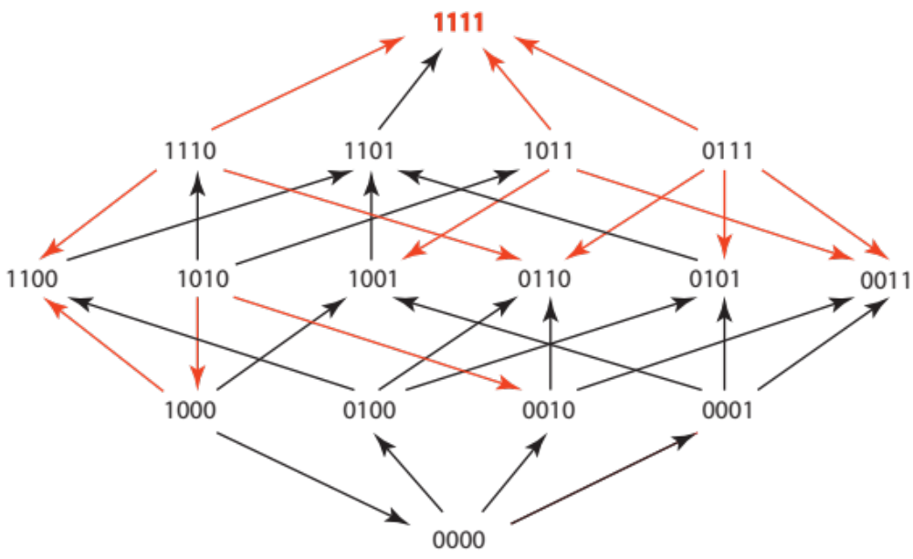

Figure 2 Amoxicillin 512 µg/ml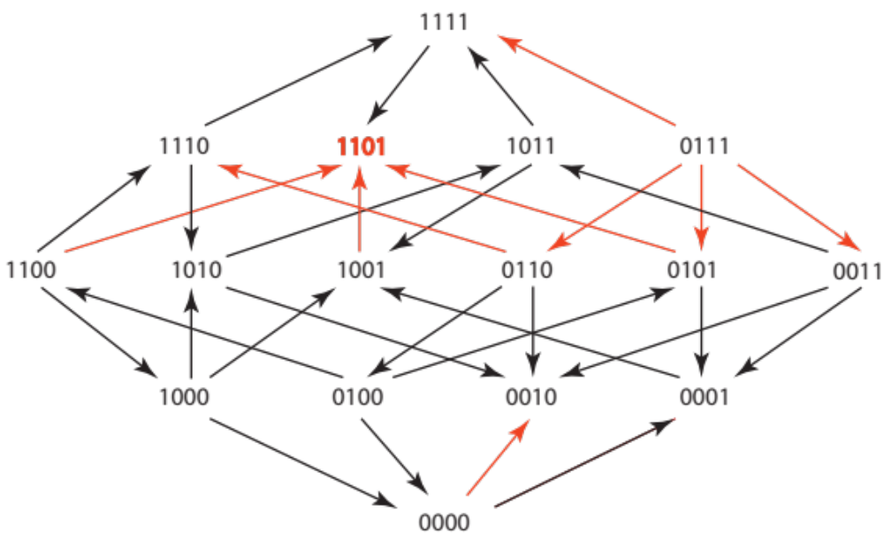

Figure 3 Cefaclor 1 µg/ml
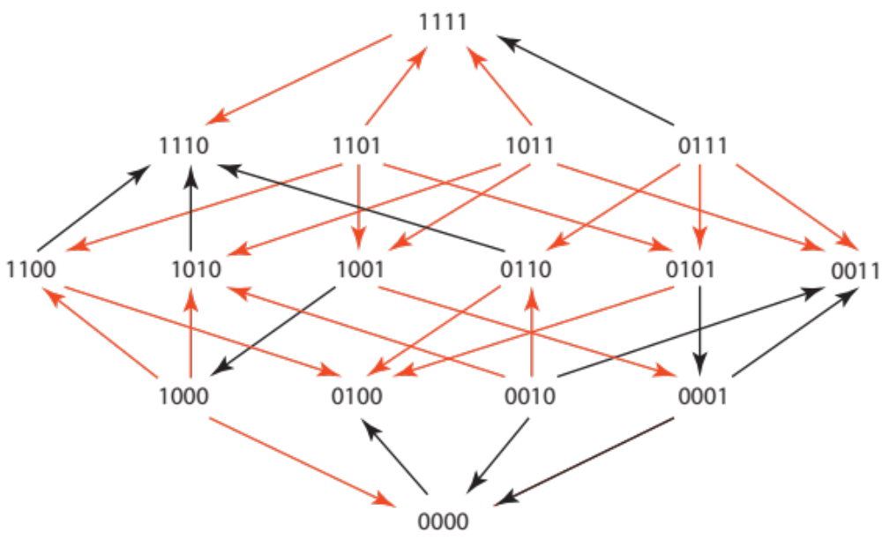
Figure 4 Cefotaxime 0.05 µg/ml
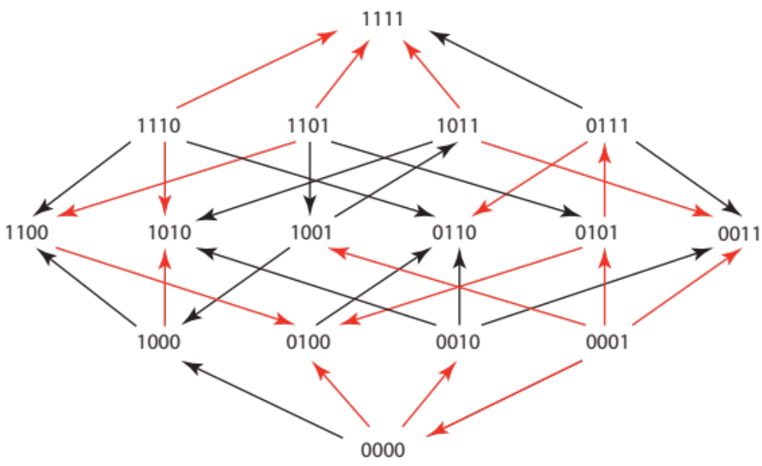

Figure 5 Ceftizoxime 0.03 µg/ml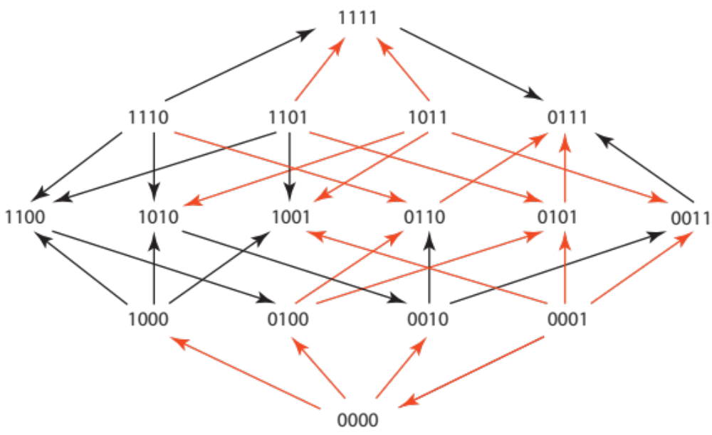

Figure 6 Cefuroxime 1.5 µg/ml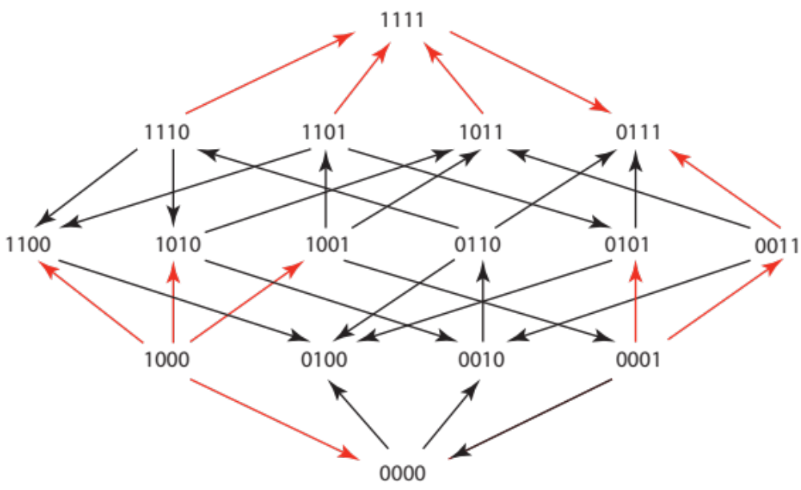
Figure 7 Ceftriaxone 0.045 µg/ml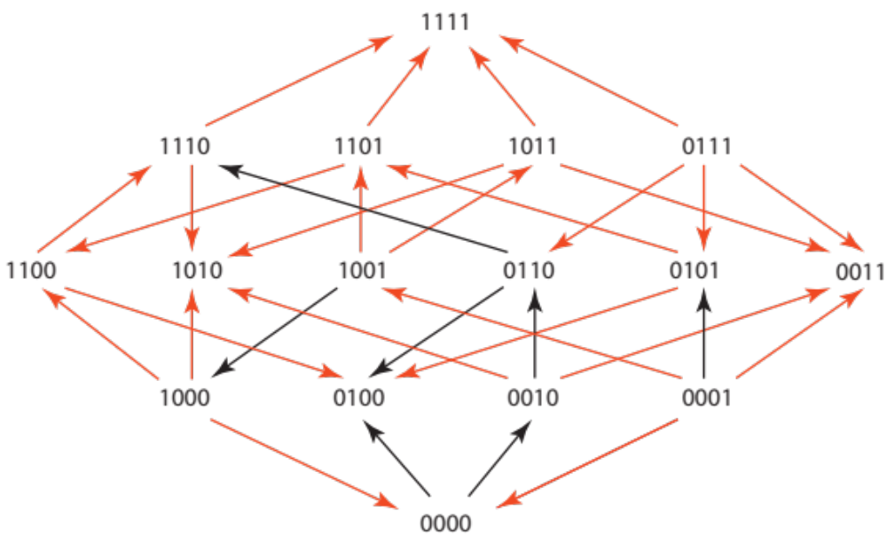

Figure 8 Amoxicillin/Clavulanate 512 µg/ml and 8µg/ml
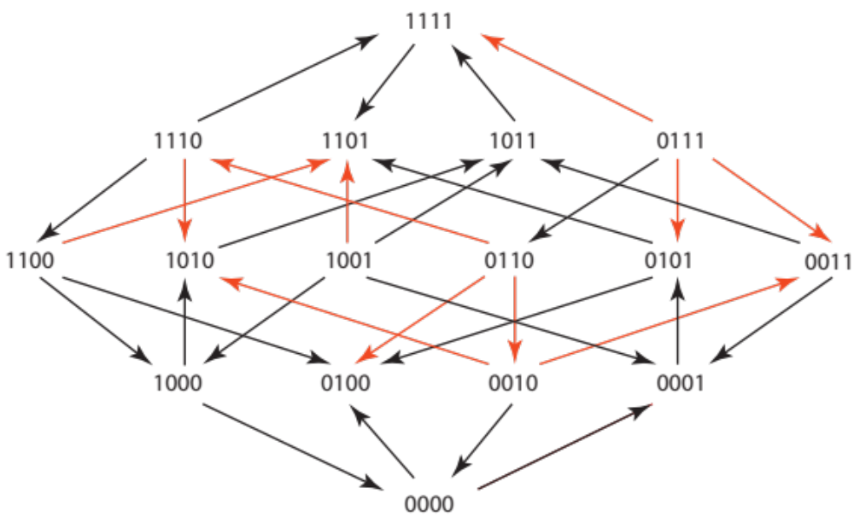
Figure 9 Cefazidime 0.1 µg/ml
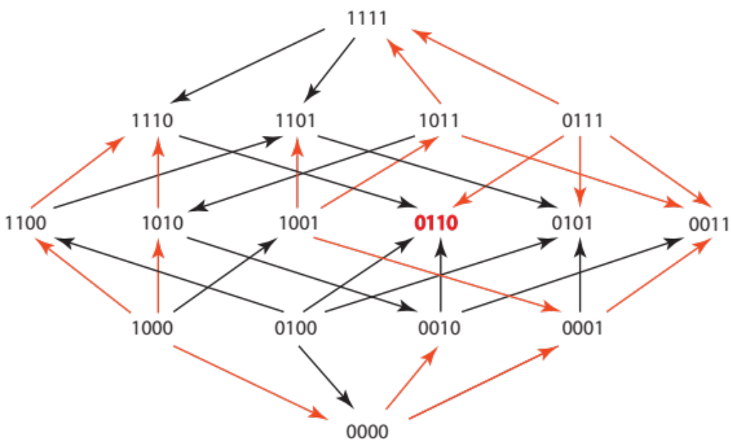

Figure 10 Cefotetan 0.312 µg/ml
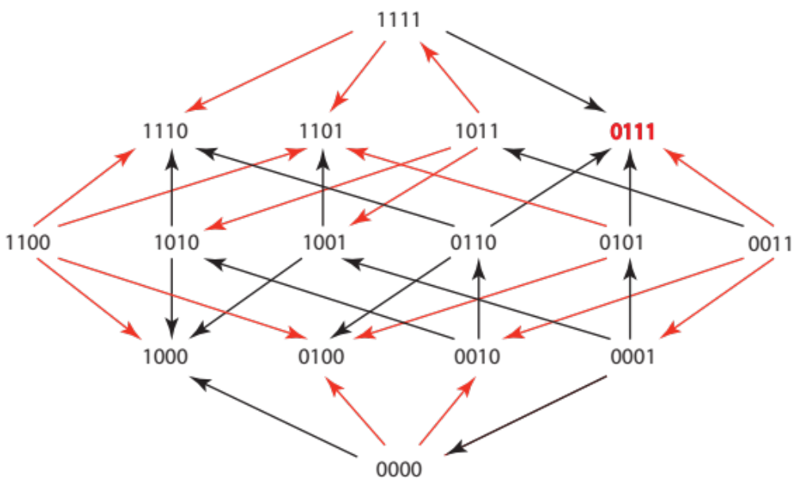

Figure 11 Ampicillin/Sulbactam 8 µg/ml and 8µg/ml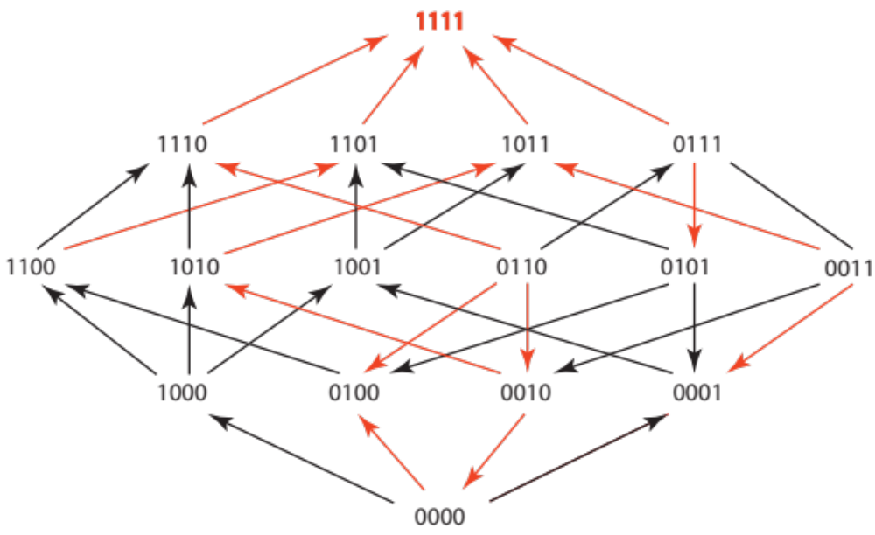

Figure 12 Cefprozil 10 µg/ml
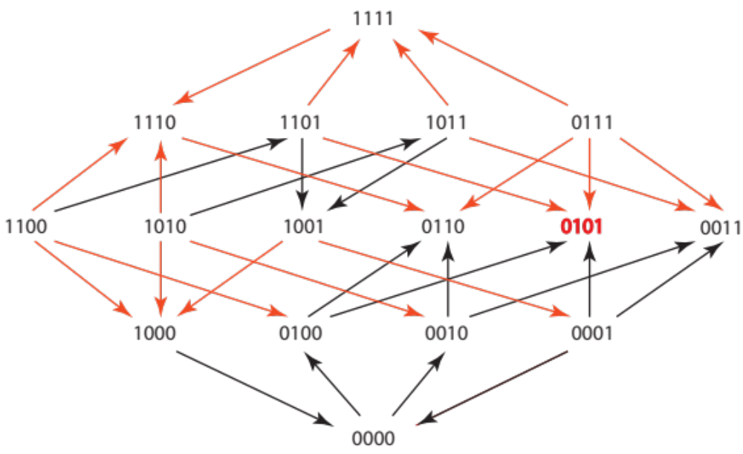

Figure 13 Cefpodoxime 2 µg/ml

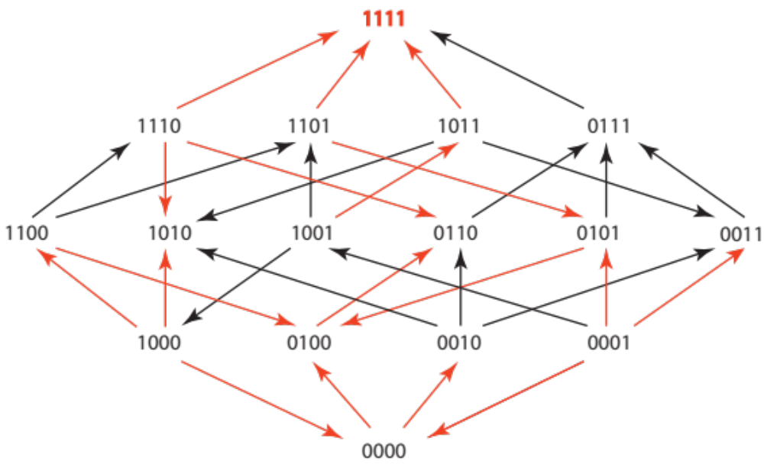

Figure 14 Pipercillin / Tazobactam 8.12µg/ml and 8 µg.ml

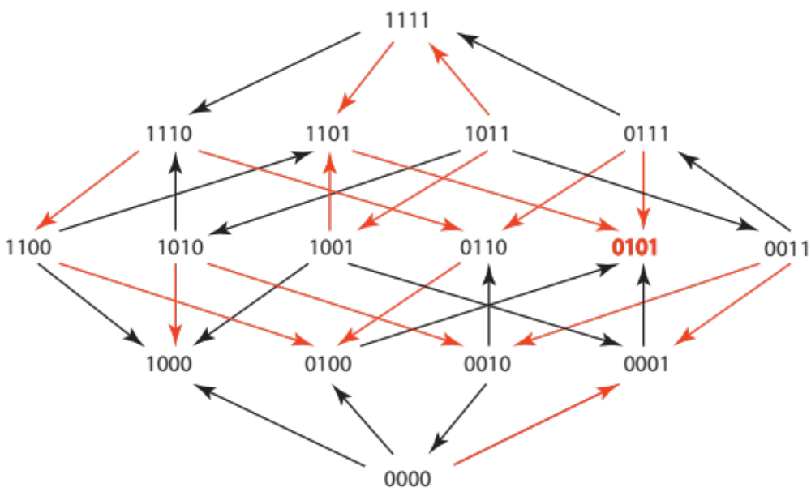

Figure 15 Cefepime 0.0156µg/ml

